Chopin's Moon
Matthew Weiss

I. Introduction
One of the obsessions of the later nineteenth century was identifying and investigating the forces that act on people’s minds. This is part of what captured the imagination of Karl Marx and later on, in a comprehensive psychology, Sigmund Freud. Both writers use the term fetish in different, but similar ways. Marx uses fetish to describe how a commodity can seem to have objective properties, such as price or value, when actually such properties are only a product of social relations. One of Marx’s influences in this regard was the philosopher Ludwig Feuerbach. In The Essence of Christianity, Feuerbach asserts that while God may appear to have an objective character, in reality, Man has simply cast an ideal notion of himself into the sky to worship. The essence of the argument is that this original relationship has long since become obfuscated and God has taken on the character of something real—a real relationship between man and himself has become transformed into a relationship between man and his illusion. In contrast, a fetish, for Freud, denotes a condition in which a certain object or part of the body becomes the object of displaced affection; sexual attraction is divorced from its natural object and concentrated in another. Both notions of fetish carry the sense of a relationship in reality becoming a different relationship in one’s mind—one, however, that seems just as real.
This essay will investigate the way in which a past populated by figures—historical figures, painters, composers, writers and their works and characters—becomes a manifest part of one’s life and how such figures stand in for parts of oneself. This process I call historical fetishism. For a certain person of person, the figures of literature, art and music are all parts of one’s psyche—they are how one gains knowledge of history in the first place and it is through them that one sees the world. The text of a book, say, its characters and above all its author, make up a real presence for this kind of person. In this way, a story can become an almost physical weight on one’s mind. Great authors of the past, great artists, composers, kings and queens fill up this person’s field of vision, as if those figures were sitting beside one; or, as if their work were a ghost only through which one could see the world. Even against one’s will, stories and books exist both on the page and in one’s reality, exerting their influence and speaking. History is written in both the volumes on one’s bookshelf and in the sky above, arcing above one’s head in a great abstraction, like the stars in the sky.
Through reading literature, through viewing paintings or hearing music, often those of canon, a fetishized relationship develops between the “reader” and the “text.” The text becomes a part of the reader; the reader and text, in fact, come to know each other personally. This relationship takes two forms. On one hand, an author might become one’s friend, one’s acquaintance. One would feel the gentle push of a whole past artistic community. The relationship between the text and reader becomes one of companionship, empathy and understanding. In a familiar way, the reader identifies with the author; in another way, the reader unknowingly becomes a bit of the author.
On the other hand, an author, text, story, even literature as a whole, might weigh on one’s mind, challenging, mocking, driving one to action, to new thought, to new works. These two aspects of the scholarly relationship compliment one another and are present in the same reader. For such a reader—and indeed, it takes a certain type of reader for this to be true—the literary, the historical become the real. They become nearly physical parts of one’s life, like one’s parents, like one’s furniture, like one’s friends. One begins to call those things within oneself by the names proscribed by the text. Indeed, the figures painted by the text come to stand in for aspects of one’s mind.
In different ways, both Søren Kierkegaard’s philosophical work Fear and Trembling and Hjalmar Söderberg’s novel Doctor Glas investigate this notion; the life and painting of Ernst Josephson epitomizes it.

II. Kierkegaard’s Obsession
The first section of Fear and Trembling is titled “Attunement.” In it, Kierkegaard describes in the third person how a man, whom we understand to be Kierkegaard himself under the pseudonym Johannes de silentio, learns the story of Abraham and Isaac as a child. The story seems simple in the man’s youth, but, Kierkegaard writes, “the older he became the more often his thoughts turned to the tale…and yet less and less could he understand it” (Kierkegaard 44). The story of how Abraham was called to sacrifice his son becomes more and more incomprehensible to the man until “finally it put everything else out of his mind” (44). The man comes to want nothing more than to have gone along with Abraham on his three day journey to the mountain Moriah, and so to have understood him.
This is the basis for the whole of Kierkegaard’s work. It is not simply the figure of Abraham that occupies him but “the shudder of thought” (44), that is, the meaning of the story: how Abraham could have had such absurd faith in God that he could both believe that Isaac would be saved from his hand at the same time that he was completely ready to give Isaac up, to sacrifice him with all the accompanying anguish and guilt implied by that word. For Kierkegaard, the figures and stories of the past are not simply obsolete relics of an earlier epoch, authority figures to pay lip service to, but testaments to the existence of questions that every generation must ask itself. In a work in the Christian tradition of devotional literature, Kierkegaard teaches us that we must actively deal with the past. But crucially, Kierkegaard asks these questions first of himself, because the story, however old and tired it may seem, weighs on his mind as if it happened yesterday. The story of Abraham and Isaac has become a waking part of his existence and the figure of Abraham comes to represent Kierkegaard’s mental confusion in the face of absurdity. For Kierkegaard’s part, he deals with the figure who haunts him through philosophy.
Indeed, as Kierkegaard writes, “I can only refer to my own experience” (146). The whole of Fear and Trembling can be read as a way of coming to grips with the past and the figures from the past which invade the present. It is no accident, then, that the central idea of Kierkegaard’s philosophy is one of action, that in the world of the mind, “only one who works gets bread” (57). One has to work hard to gain an understanding of life, oneself and one’s time. One has to actively engage with the enigmatic figures of the past in order to deal with the present. Kierkegaard’s own philosophical method reflects this.
On one level, Fear and Trembling is about trying to understand the “monstrous paradox which is the significance of [Abraham]’s life” (81) and to turn that understanding into part of oneself, to realize that the ability to have faith is granted to everyone, that “no human being is excluded from it” (95). Kierkegaard writes in the Epilogue that,
Whatever one generation learns from another, it can never learn from a predecessor the genuinely human factor. In this respect every generation begins afresh, has no task other than that of any previous generation, and comes no further, provided the latter didn’t shirk its task and deceive itself. This authentically human favor is passion, in which the one generation also fully understands the other and understands itself. (145)

Here, Kierkegaard sees a continuity between generations, but not a progression. It is no use “being born into the most enlightened age” (75) if one is not willing to take seriously the wisdom of generations past. Often Kierkegaard talks about those who “feel their lives unrelated in even the remotest manner to those of the great” (92), giving the example of a minister who retells the story of Abraham, without ever exploring the real implications to the nature of faith that it implies. When a man in the audience takes the minister’s sermon to heart and murders his own son, the priest takes great pleasure condemning him. “Is it because Abraham has acquired proprietary rights to the title of great man, so that whatever he does is great, and if anyone else does the same it is a sin, a crying sin?” (60) Kierkegaard asks. The problem, in Kierkegaard’s eyes, is that too often the past is treated as a given. We, in the present, can fall to easily into the trap of thinking we stand at the pinnacle of history and need not look down. But Kierkegaard tells us that the members of each generation must relearn the lessons of past generations, must understand stories like Abraham’s on their own terms and understand it in relation to themselves.
But on another level, however, Kierkegaard’s work draws our attention to the fact that while some can take paradoxical figures like Abraham for granted, others are obsessed by him. Indeed, if each generation comes no further that the previous, then the figures of the past sit right beside us. And clearly, while there are those who ignore the past, there are those cannot forget it, like Kierkegaard himself who addresses Abraham directly, reverently: “[I] will never forget that you needed a hundred years to get the son of your old age, against every expectation, that you had to draw the knife before keeping Isaac; he will never forget that in one hundred and thirty years you got no further than faith” (56). Although Kierkegaard frames Fear and Trembling as a work in the tradition of devotional literature and draws out lessons about the past and faith that apply to everyone, Abraham, for Kierkegaard, is more that just an example, a model to illustrate a lesson, however profound or demanding that lesson may be. Kierkegaard exhorts the reader to deal actively with the past because that is what he has found to be his experience: the basis for his work is personal. In fact, his work is a way to deal with his obsession. Abraham, then, is not an intellectual abstraction for Kierkegaard. When he thinks about Abraham, in fact, he tells us that he, personally, is “virtually annihilated” (62). For Kierkegaard, the past is tangible. It presses on his back and harries him because “not just the memory of the chosen lives on but the chosen themselves” (93). Figures passed down through stories do not remain locked in the confines of books; they become living presences that take lifetimes to understand.
Why?
They are inescapable because they are the faces of parts of ourselves that demand explanation.
Abraham becomes the symbol for the absurd level of faith that Kierkegaard claims he can never attain. “The hero I can think myself into, but not Abraham; when I reach that height I fall down since what I’m offered is a paradox.” (63) Through the process of historical fetishization, Abraham, the historical-literary figure stands in place of all the mental confusion and “holy terror” (90) Kierkegaard experiences. In this way, Abraham appears not so far off; in fact, Abraham is as close to Kierkegaard as the psychological processes which grant him such power over the philosopher’s mind.
Kierkegaard writes that “it is against my nature to do what people so often do, talk inhumanly about the great as though some thousands of years were a huge distance; I prefer to talk about it humanly as though it happened yesterday…” (64). The dichotomy implicated here is that there are two kinds of people: those who feel the past right beside them and those who do not. Kierkegaard certainly wishes there were more of the former and while the process of historical fetishization happens, to some degree, to everyone, for a certain type of person, historical influence is inescapable. Applying this psychological analysis to Fear and Trembling, Kierkegaard is one of them.
One can tell by the language he uses. He describes the tragic hero:
The tragic hero…seeks out the one whose soul is beset with sorrow, whose breast cannot draw air for its stifled sighs, whose thoughts weighed down with tears, hang heavy upon him; he appears before him, he breaks the spell of grief, loosens the corset, coaxes forth the tear by making the sufferer forget his own suffering in his. (89-90)

Although he contrasts the tragic hero with Abraham, the knight of faith, whom “one cannot weep over,” the essential idea is the same. Heroes, tragic or otherwise, from the past can have direct influence over one in the present. Nor does Kierkegaard limit himself to heroes alone. In fact, he addresses the authors themselves as if they were beside him:
Thanks! And thanks again, to whoever holds out to one who has been assaulted and left naked by life’s sorrows, holds out to him the leaf of the word with which to hide his misery. Thanks to you, great Shakespeare!, you who can say everything, everything, everything exactly as it is—and yet why was this torment one you never gave voice to? Was it perhaps that you kept it to yourself, like the beloved whose name one still cannot bear the world to mention? (90)

Kierkegaard uses apostrophe for rhetorical effect, but the degree of familiarity that he uses in speaking to Shakespeare leaves one with the inescapable suggestion that Kierkegaard is personally close to the bard. The words he uses—“you who can say everything, everything, everything”—suggest great love and respect, suggest that Kierkegaard has spent time with Shakespeare. It suggests that one can gain friends, not just outside, but inside, in the privacy of one’s own study. Although Kierkegaard brings up the tragic hero, whom he can relate to, in contrast to Abraham, the incomprehensible, that basic phenomenon that Kierkegaard hints to is the same. Whether one can understand them or not, for someone like Kierkegaard, the figures of the past speak and cannot be ignored. Thoughts are manifest: Kierkegaard writes at the end of his Epilogue about Heraclitus ‘the obscure’ whose “thoughts had been his armor in life, which he therefore hung up in the temple of the goddess” (147). Thoughts, ghosts have weight, they can be seen, heard and above all, touched.

II. Doctor Glas and the “Ensemble of Social Forces”
At the very beginning of Hjalmar Söderberg’s Doctor Glas, in order to describe his feelings for the Reverend Gregorius, the novel’s eponymous anti-hero, Tyko Gabriel Glas, retells an anecdote about Schopenhauer: the philosopher was sitting alone at a café when a “person of disagreeable mien” (Söderberg 13) enters the room. Schopenhauer “leaps up” (13) and beats the man with a stick. Glas concludes, “Well, I’m not Schopenhauer” (13). The irony is evident; by the end of the novel, the disagreeable Rev. Gregorius is dead and Glas, very nearly, has become Schopenhauer. It is no accident that the arc of the novel follows the path laid out by the anecdote on its very first page. The novel’s format is a diary in which Glas attempts to record his thought processes which, eventually, lead to murder. As the novel progresses, it becomes clear that Glas’s aim is to dissect his own identity. He sees himself as an “ensemble of social forces” (Tucker 145), to use a phrase from Marx, a symposium of conflicting and contradictory inner voices deriving from the world around him. Through a kind of literary psychoanalysis, Glas attempts to find the sources of each of the voices that speak discordantly inside his head, the sources of his neuroses, his persona. The forces that make him up are many: social forces, indeed, play a great role, including the influence of events in his youth. But above all, the force of historical figures in art, music and especially literature shapes Glas’s identity. Indeed, throughout the novel we see the pervasive influence of historical fetishism. For Glas, quotations and allusions are the terms by which he describes the world; they symbolize aspects of himself. Indeed, without recourse to them, his identity is unstable. At one point in the novel, he finds an old piece of paper with a note jotted down on it and wonders, “When did I write that? Is it some reflection of my own, or a quotation I jotted down?” (Söderberg 70). He cannot remember. For the solitary Glas, literature provides him with his friends; it also mocks him for his cowardice, his inaction and his passivity. Historical and literary influence build up in Glas’s mind, clogging his psyche, until eventually, at the novel’s end, he abandons his self-dissection as futile. Understanding does not bring him any closer to denying influence its power and before he can hope to leave behind the voices which harrow him, he must first accept his own identity.
Doctor Glas, despite his one great action in the form of the Reverend’s murder, is ultimately a passive character. He describes himself as having “the solitary person’s constant desire to see people around me—note bene, people I do not know and so do not have to speak to” (54). Not only does he not act, but he lacks the ability to see himself acting. Even in his imagination, he is absent. As he writes: “And even if from time to time I lay awake at nights, indulging myself in hot fantasies, yet it always seemed to me unthinkable that I should find satisfaction with the women my comrades visited…” (29). Further, because he cannot imagine himself, he must use others to see the world for him. Principally, literary and historical figures provide the language that Glas uses to describe the world.
In one lengthy passage, he makes his debt to literature and art explicit:
I often wonder, too, what character I should prefer for myself had I never read a book or seen a work of art. In that event perhaps it would not even occur to me to choose—perhaps the archipelago, with its rocks, would do for me. All my thoughts and dreams about Nature are most probably based on impressions drawn from poetry and art. From art I have acquired my longing to wander at east in the ancient Florentine’s flowery meadow and nod on Homer’s seas and bend the knee in Böcklin’s sacred grove. (58)

The chief problem in any kind of analysis of humans is separating what is primary and what is secondary, what naturally arises from the human mind and what is conditioned by the various forces that act on us—forces that, natural forces aside, ultimately derive from other people, past and present. But whether or not Glas would be the same person without his exposure to literature, to art or music is irrelevant; that we cannot know. For us the relevant fact is that he employs the language of culture, of literature, music and art as terms of expression to describe the world. Further, it is not as impersonal symbols that he treats Homer and Böcklin; they do not simply signify the way words do. For Glas, Homer and Böcklin are alive; the whispers of multiple generations explain to him everything he encounters in the world:
Alas, what would by own poor eyes see of this world, left to themselves without all these hundreds and thousands of teachers and friends among those who have sung and thought and seen on behalf of the rest of us? (58-59)

Above all, when literature, when great historical figures, when the past is fetishized, it is never an impersonal, intellectual process. Even if the voices of the past are harrowing, as Glas discovers as he becomes mired in deliberations over Gregorius’s murder, nevertheless the voices are our own; they are our “teachers” and, especially, our “friends.” This is more than simply relating to or identifying with other people, past or present; when the past is fetishized, our favorite authors become a part of our everyday life, sitting with us when we dine alone, walking with us down the streets at night. They show us parts of ourselves, they give us our eyes:
And what am I? … I have no eyes of my own. I can hardly see the drinks and radishes on the table, over there, with my own eyes; I see them with Strindberg’s and think of a supper he ate in his youth at Stallmastaregarden. And when the canoeists flew past on the canal, just now, in their striped vests, it seemed to me for a moment as if the shade of Maupassant fled on before them.
And now, as I sit at my open window, writing this by a flickering candle…now, as the candleflame flutters in the draught and my shadow shivers and flutters like the flame on the wallpaper, as if trying to come to life—now I think of Hans Anderson and his tale of the shadow. And it seems to me I am the shadow who wished to become a man. (60)

When Kierkegaard dealt with the weight of Abraham on his mind, the philosophy he expounded was primarily an active one: he taught us that one should take one’s ghosts in hand and treat them seriously, to understand them on their own terms, and see how those terms are not so different from one’s own. Glas’s analysis, in contrast, is primarily passive. Instead of treating his ghosts as separate, he allows them to make up his identity. He lives vicariously through the characters he reads, through the lives of authors, or painters. He leeches off their experience and makes it his own. He has no independent, active identity: indeed, he is “the shadow who wished to become a man” (60). His own life, then, is a shadow cast by the forces which went into his being, forces whose faces are of the historical figures themselves. And if he sees the world, necessarily, through the lens of literature, the world takes on the form of literature. He writes that “I … am a born looker-on, [I] want to sit comfortably in my box and see how people on a stage murder each other, while I myself have no business there” (99). But however much he “want[s] to sit comfortably,” the very figures whose eyes he sees through call him, frustratingly, to action.
He hates himself for that contradiction. While he vacillates over Gregorius’s murder, the people he idolizes, those who act—“I’ve read Raskolnikov, I’ve read Thérèse Raquin” (100)—tell him via his own thoughts, “Trash! You’re just trash!” (99). And when he does act, the impulse to murder is shaped by the voices in his own head, voices bearing the examples of the past, voices which eventually, after he kills Rev. Gregorius, go wild: “I sense the enormous atmospheric pressure of others’ opinions; the living, the dead, and the still unborn, gathering out there, threatening to blow down the door and crush me, pulverize me…” (124). Glas thinks he cannot be rid of them; instead, he works at identifying them. “I want to (murder Gregorius); and I don’t want to. I hear conflicting voices. I must interrogate them; I must know why the one says: I want to, and the other: I don’t want to” (93). The whole novel is the process by which Glas attempts to understand the forces that make him up. His difficulty lies in that he assumes his development is over, that all he can do is to pick apart what has already been created. His path, then, is self-determined. He, passive, allows the souls of generations past to flow through him, allows them to justify his murder.
As Glas deals with his conflicting feelings after murdering the Reverend, the influence of his “friends” overtakes him yet again:
There’s something wrong with my brain. I don’t know whether it’s too bad, or too good; but certainly, it isn’t what it ought to be…Why are the two little trees by Bellman’s grave so thin and wretched?...He should be sleeping beneath great sighing trees, old Carl Michael. Sleep, yes—are we allowed to sleep? Soundly? If one only knew—two lines from a famous poem come into my head: ‘The shade of an old poet wanders in the roof-gutters, its voice sad as a frozen ghost’s.’ Luckily for Baudelaire, he never had to hear what it sounds like in Swedish. (131-132)

As he writes, Glas visually places Bellman’s grave in his room, his physical location. For him, “old Carl Michael” is as real as Kristin, his maid. His brain is both “too bad” and “too good,” in the sense that it is too rational. Glas’s overthinking of his own influences is what denies him sleep and, indeed, he comes to this conclusion himself, towards the end of the novel: “Perhaps we aren’t intended to understand life? All this rage to explain and understand, all this chasing after truth, perhaps it’s a wrong turning?” (147). As Glas goes after the truth behind the forces that constitute his psyche, he is ultimately frustrated. Although he come to know the faces of the forces that make up his being, he cannot let them go; they are as part of himself as he is. Indeed, they are him. For that matter, whether he chases after truth or not, he remains the kind of person who immerses himself in others. The very idea of keeping truth at a distance is a restatement of an idea put in his mind pages earlier by his friend Markel who says that one must “preserve a correct and satisfactory distance from the truth” (138).
Doctor Glas is another example of the type of person we first encountered in Kierkegaard. He is someone who sees and interprets the world via the figures of ages past. He, like Kierkegaard, is the type of person who hears poets wandering above him, their “voice[s] sad as a frozen ghost’s,” haunting and driving him forward. Glas’s friend Markel tells him that “it would be difficult to find a more striking instance of the toughness of tradition than the fact that the most popular almanacks are full of detailed information which no living person any longer cares a fig for” (76). As in Kierkegaard, a dichotomy is erected between those who remember and those who forget, between those who cannot let the past go and cannot escape it and those who ignore it. Glas, and Kierkegaard, for that matter, are trapped with the past.
Glas references Nietzsche to justify his interpretation of Eva Martens, the woman whose affection he constantly ignores: “Here go many virgins, whom no man has yet touched, and who do not thrive by sleeping alone. Thus, more or less, spake Zarathustra…” (84); he references Marx to describe Mrs. Gregorius as “a woman from primitive folk, or one that never existed, where class distinctions had not yet become, where ‘the people’ still had not become the lower classes.” (110) He reflects on the first woman he denied an abortion to: “…a big, dark-haired, rather vulgar young beauty, the sort, you could see at a glance, which must have filled the earth in Luther’s day…” (17). Later on he compares a portrait of Rev. Gregorius’s wife to “good Catharine of Bora” (27). Indeed, these and other’s voices make up the tools he uses in his attempted analysis of the forces that make him up; these are the origins of the arguing voices who deliberate on the pages of his diary. The voices of Nietzsche, of Marx, and those of Raphael, Steinlin (20), of Demosthenes (102), of Pascal, Fénélon, Queen Margot of Navarre (131), King Herod (146), Oedipus (147) and myriads more make up the faces of the historical-literary forces at work inside Doctor Glas, the forces that make him up, the forces he can often identify, but, ultimately, do nothing about.
Indeed, Glas understands this phenomenon, indeed, the phenomenon of historical fetishism in general and, in one passage, he describes it with grace and poetry. He shows us how the forces of things we have read, of what people have said, and what we have experienced can become disconnected from the experience of reading or listening and become associated with, that is, fetishized into, concrete figures and forms that haunt the imagination. He shows us how one thing can stand in place of many things, how one shape can contain an entire mingling chorus from the experiences of one’s life.
He shows it to us in his discussion of “Chopin’s moon” (86). Glas, sitting at his writing desk, as usual, looks out his window at the moon. He tells us,
I remember so many moons. Oldest of them all is the one that perched behind the windowpanes in my childhood’s earliest winter evenings…Once my mother read Viktor Rydberg’s The Christmas Goblin aloud to us children; I recognized it at once. But it still had none of the characteristics it was later to possess. It was neither wild nor sentimental, nor cold and horrible. It was just big and shiny… (86)

He remembers how he took piano lessons as a child and writes that “One night, I was about twelve then, I remember lying awake, unable to sleep because I had Chopin’s Twelfth Nocturne running through my head, and because of the moonlight” (86). As Glas will show us, all of his experiences with the moon, all that those experiences represent, become fetishized in the form of the moon. The moon, as he says, comes to take on “characteristics” like “wild or sentimental,” characteristics that lie outside the realm of physical description and imply that some other things have gotten caught up with the moon in Glas’s mind. The music of Chopin, Chopin the composer, the shining moonlight, childhood and sleeplessness are all bound tightly together in the form of the moon, as if the moon itself possessed those characteristics. Such things are beyond conscious control; Glas writes that “I sat upright in bed and sang. I had to sing that wonderful wordless melody that I couldn’t get away from. It melted into moonlight and in both lay a promise of something tremendous, something to be my lot one day…” (86). The process of music melting “into moonlight” is an involuntary part of the mind; Glas, through analysis, seeks to draw it out. Although he identifies it, he is unable, nevertheless, to move beyond it. Indeed, forever, “that was Chopin’s moon” (86).
Throughout the course of Glas’s life, the moon takes on more and more characteristics, which build up and clog his memory. “And it was the same moon which afterwards shivered and burned over the water on August evenings when Alice sang. I loved her. Then, too, I remember my Uppsala moon…” (86-87). Glas describes walking in Uppsala with “an older friend” (87). They “[talk] philosophy” (87) and Glas is disgusted with his friend’s Darwinism, which, Glas says, makes things out to be “meaningless, stupid and squalid” (87). For Glas, the influence of his dealings with Darwin provide the front for all his feelings about sex, a rationalization and a figurehead for his shyness and passivity. Early in the novel, Glas crosses a churchyard and is disgusted when he sees “one of those scenes of which letters to the newspaper are in the habit of saying they ‘defy description’” (28), that is, two people having sex. His refusal to be intimate with anyone, his disgust for his own body (“…I felt as ugly as the devil…” (35)), get tied up in literature, in writing: in the former case, in Darwin, in the latter, in the newspapers.
In Uppsala, Glas describes how he thought to Darwin, in the same way that Kierkegaard thinks to Shakespeare: “You’re wrong, but I still haven’t studied or thought enough to be able to refute you. But wait—wait just one year, and I’ll come back to this same spot with you, in the moonlight, just like it is now, and I’ll prove how wrong and stupid you are” (87). His friend waves the German volume “out of which he got his arguments” in Glas’s face, and in an act which is surely as allegorical as it is literal, he shows Glas an illustration and a text. Glas writes, “The moon shone so brightly I could both see what it represented and read what was written beneath. It was a picture of three craniums, rather similar: the skulls of an orangutan, an Australian aborigine, and of Immanuel Kant. Seized with loathing, I flung the book away from me” (87-88). The German book, on one hand, imparts to Glas its literal meaning, that is, what it says. But at the same time, the German book, the illustration, the moonlight illuminating them, all carry along a depth of emotion, carry and come to stand in for Glas’s feelings about physicality and sex. Indeed, he flings the book away from him because Kant, the great idealist, and Glas’s “friend” is being materialized, soiled and cast into squalor. Thus the moon gains another dimension.
Glas goes on:
And many moons I have seen since then. A mild and sentimental moon between silver-birches by the lakeside…The moon scurrying through sea-mists…the moon fleeing away through ragged autumn clouds…the lovers’ moon which shone on Gretchen’s garden window and Juliet’s balcony… A girl no longer young enough who wanted to get married told me once that she could not help crying whenever she saw the moon shining over a little wooden cottage in the forest…the moon is passionate and desirous, says the poet. Another tries to find a tendentious ethical-religious meaning in moonbeams, likening them to threads the dear departed spin into a web to catch errant souls in. For youth the moon is a promise of all those tremendous things which await it, for older people a memento that the promise was never kept, a reminder of all that broke and went to pieces… (88)

For everyone, the process of fetishization works differently. The physical world is not a collection of disconnected, impersonal objects. Everything is imbued with feeling by human being, carries with it emotional power and provides a face and a name for the forces that make up our being. Not only can one fetishize world history, but also personal history. Glas’s description of the philosopher could have described Kierkegaard. In both cases, the philosopher starts with a difficulty, a weight on one’s own mind, and then rationalizes it, turns it into a theory, a philosophy and an explanation. Glas’s diary works in a similar way. Both Glas and Kierkegaard use analysis, use philosophy and literature to deal with their obsessions. What Glas describes in the passage above are all different ways of dealing with the past via an object, via a figure, via an author or a novel. The difficulty in dealing with the past using figures is that we try to understand and explain the object of our obsession, but miss seeing the reason the object inspires such feeling. This is what Glas is hinting to in the passage; that is the reason for his catalogue of moons. Glas, in fact, sees both: he sees what the moon is and has come to represent and why. And yet, ultimately, such a catalogue comes no closer to healing his tortured mind. Passive intellectualizing gives him nothing. One can identify one’s fetishes, but one can’t escape them. Indeed, they make up one’s being. The moon remains a fetish, no matter how much Glas understands why. As he concludes:
And what is moonshine?
Secondhand sunshine. Diluted, counterfeit. (87-88)
III. Ernst Josephson’s Historical Insanity
In the case of Kierkegaard and Doctor Glas, to say that historical figures are manifest in their lives is to speak metaphorically; the metaphor of the physical world aptly describes the occupation of their minds by figures like Abraham or Nietzsche as placeholders for their own inner obsessions. But in the case of Ernst Josephson, who, in 1888, on the island of Bréhat off the coast of Brittany in France, succumbed to schizophrenia, historical figures truly became a physical presence in his life. In fact, that summer, the Swedish painter became “obsessed with the idea that he was St. Peter, keeper of the gates of heaven, chosen by God to hear the confessions of the spirits before they were permitted to pass on to eternal salvation” (Blomberg 12). Alone in a cottage, abandoned by all but one friend who traveled to Brittany with him, and denied the critical acclaim he thought he deserved, Josephson came to believe that “kings, artists, poets and prophets alike…heralded his new state of divine authority, while through the medium of his hand their confessions and messages were recorded, often accompanied by schematic profiles of the spirits themselves” (12). He compiled a collection of drawings known as the “Spirit Protocol” (Weinstein 380), a record of the souls who came to seek his approval. In addition, he completed a set of drawings and paintings signed with the names of old masters like Rembrandt, Raphael or Velasquez. Here, what was implicit in the voices in Doctor Glas’s mind, that one is made up of a collection of influences, influences with faces and names that one can talk to, listen to and think of as friends or enemies, is here, in Ernst Josephson’s mania, made painfully explicit. Josephson’s training, his megalomania, his fragile cohesion of self are laid bare for all to see.
Josephson, like Glas, like Kierkegaard is well educated. As a child, he “sang, sketched, acted in amateur theatricals of various kinds, and wrote romantic verse” (Blomberg 9). He enters Sweden’s Royal Academy of Art in 1868 (9) and wins an Academy award, allowing him the resources to travel to Holland and Italy to, in his words, “drink from the inexhaustible springs of the old masters” (10). Indeed, he spends much of his early career immersing himself and copying the great painters of the past. In Amsterdam, he copies Rembrandt’s The Night Watch and The Five Syndics and in Florence and Rome, imbibes the styles of Raphael and Titian. He himself in 1881 is compared to Velasquez and Manet: “For Josephson this was not simply imitation but careful preparation for the purpose of creating works with the same rich, full-toned spirit of humanity as the classical masters themselves” (10). His stated goal is to “become Sweden’s Rembrandt or die” (10). Just as Abraham stands in for Kierkegaard’s metal confusion over the absurd nature of faith, just as Glas cannot not see the drink in front of him because Strindberg’s is getting in the way, Rembrandt and the rest of the old masters, in fact, stand in and become the fetishized faces for Josephson’s ambition. Josephson comes to believe that the key to his success as a painter does not lie within himself, but rather is something external, something removed from him in the form of artistic canon.
Both Kierkegaard and Glas find difficulty in dealing with their fetishes, which provide both a sense of comfort, as well as a sense of inadequacy and, accompanying that, anxiety. Kierkegaard explicitly advocates actively dealing with the past; if Glas had taken active control over his own influences and accepted them, perhaps he would have met with less frustration. Once Josephson’s schizophrenia, which was “hereditary in his family” (12), overwhelms him in 1888, he is literally haunted by the masters of the past: no longer bound by the chains of sanity, the feelings of smallness and awe that accompanies the viewing great works is let loose, and as the faces of all those whom Josephson came to know, love, respect and venerate swirl around him. He, like Glas, like Kierkegaard, has to find some way to reign them in, assert control over them, deal with them actively. The result is the Spirit Protocol.
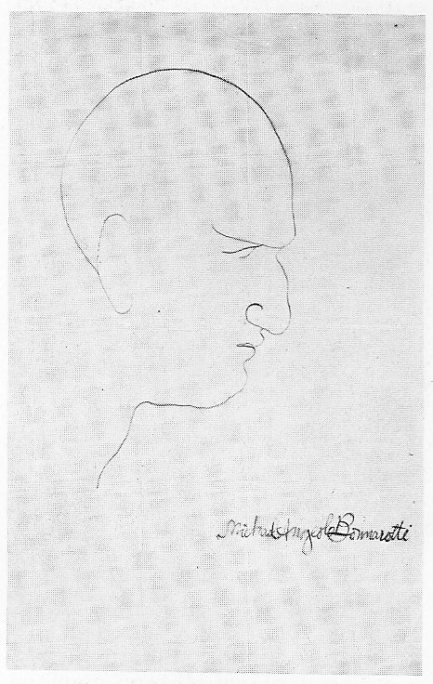
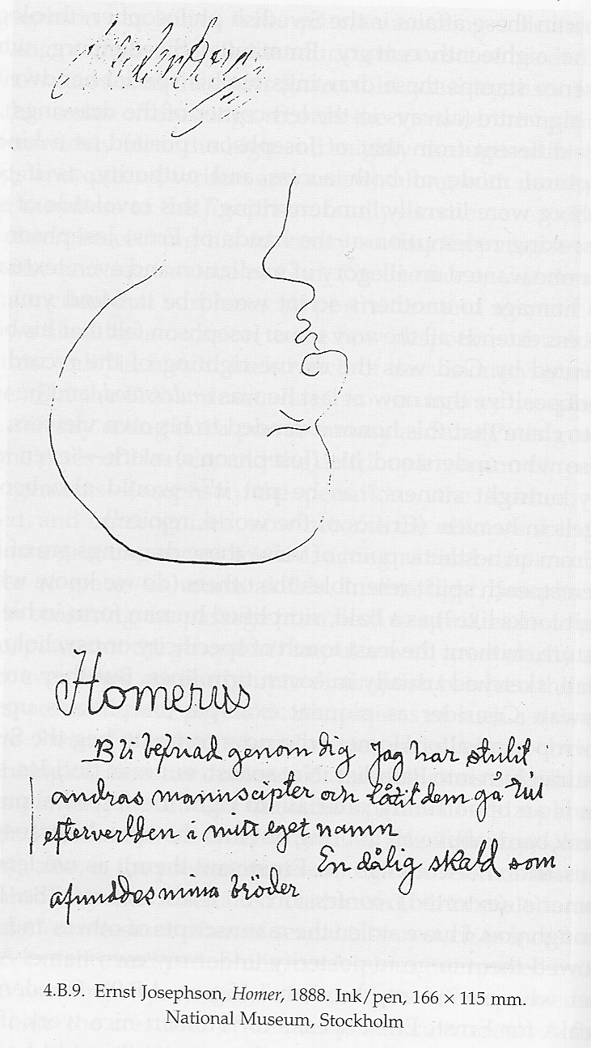
Indeed, it was not simply artists who visited Josephson, but all the figures of the past who exerted control over him. To the right is Josephson’s record of the poet Homer’s arrival in his cottage. The text in Swedish reads, “Be freed through you. I have stolen the manuscripts of others and have allowed them to go to posterity under my own name. A bad poet who envied my brothers” (Weinstein 381). In the figure of St. Peter, Josephson is able to actively master his fetishes, able to work through the influences that make him up. Homer is depicted with a minimum of lines. He is upside down, bald, defenseless. He is stripped of the signs of his office; there is nothing to differentiate the spirit of Homer from the spirit of any other, no sign of the poet’s mastery of words, no symbolism of the grace and humanity that makes Homer, well, Homer. Further, as in all the drawings of the Spirit Protocol, in the upper-left corner is the signature of the Swedish theologian Swedenborg (381). Josephson, it seems, again needs to derive his authority from some source outside himself. His dependence on the past, his own feelings of smallness in the face of the great works of history, is cast into vivid light: even gripped by delusions of grandeur, believing he is chosen by God himself, Josephson still needs a cultural authority figure to justify his judgment over Homer.
Further, the confessions of the spirits who visit Josephson are “confessions often of sexual taboos such as incest and homosexuality and pedophilia, confessions interpreted by the critics as so many projects of the artist’s own repressed desires onto the creatures of his fantasized courtroom” (380). Again, as in the cases of Kierkegaard and Doctor Glas, the faces of influence become the symbols of one’s own problems, obsessions, difficulties. In such cases, the temptation is to treat the symbol as the thing itself; to condemn Homer for stealing “the manuscripts of others” and envying his “brothers” when what one is really worried about is one’s own inadequacy in the face of the great weight of past achievement.
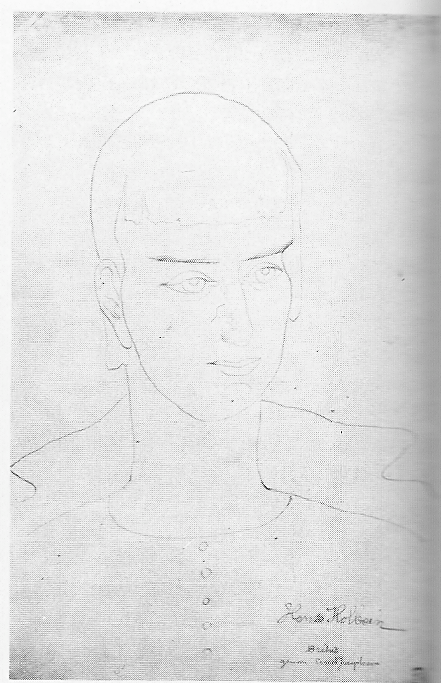
In the same fashion, we find, along with Homer, artists like Michelangelo, above, and Hans Holbein, to the right (Hill 132). Others include “Dante, Walter Scott and Byron” (Weinstein 384).
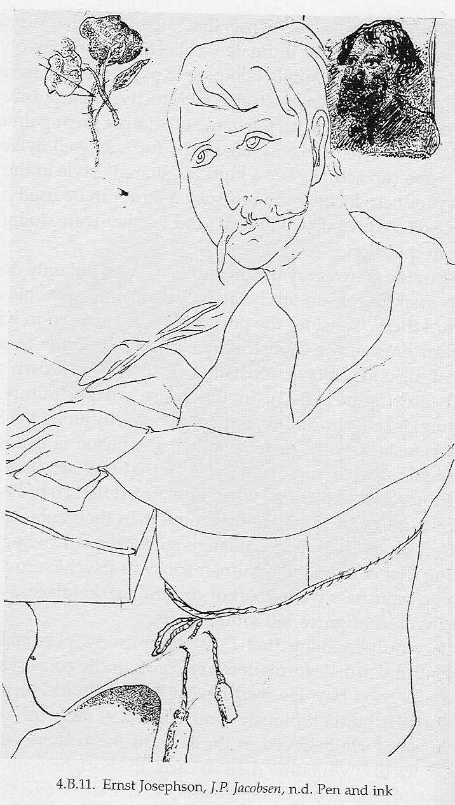
Again, the artists are denied any distinction, no weight is given to their accomplishments. Josephson has not only become “Sweden’s Rembrandt,” but surpassed him. In a different way, in his depiction of the Danish novelist J. P. Jacobsen, right, (Weinstein 388), we see this power relationship explicit. The novelist is sitting at his desk, a look of concentration, anxiety perhaps, on his face. In the background, in a painting hanging on the wall, or perhaps in a mirror, is the face of Josephson himself. Jacobsen, the ostensible subject of the work, is drawn with a minimum of lines; Josephson, on the other hand, is completed in great and intricate detail. He stares down at Jacobsen from the wall, passing his judgment on the writer’s work. Whereas in reality, Josephson is in the powerless position, at the mercy of Jacobsen’s successful example, in the drawing, Josephson accompanies Jacobsen at every turn, is present as each word is written, and only then, allows the work to come to fruition.
Another manifestation of this same phenomenon is in the “Trance Drawings,” (Blomberg 36) which are done in the names of the great masters. Josephson completed works signed with the names of Hans Holbein, Rembrandt, Michelangelo, Raphael (below, right) and Velasquez (below, left).
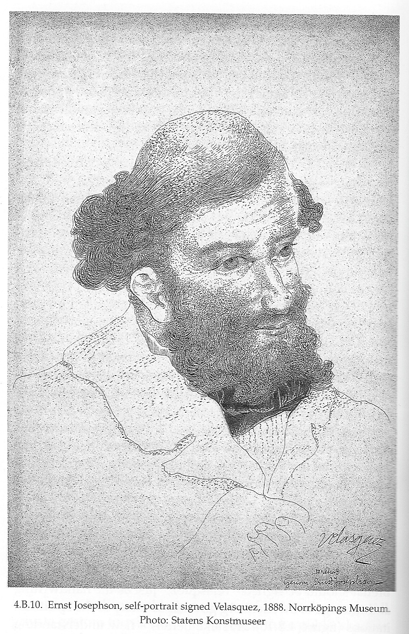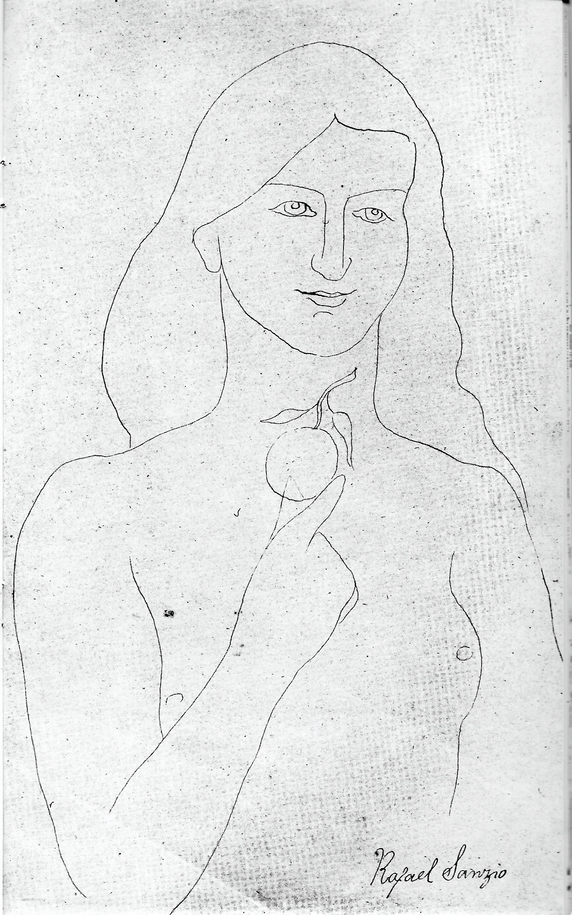
Josephson, we know, spent much of his life copying these great masters. Now he not only imitates them, but becomes them, because for him, they are the fetishized figures of success. He, like Homer, envies “his brothers.” Indeed, the use of the word “brothers” suggests the same kinds of feelings that Glas describes when he talks about his “teachers and friends.” Josephson signs a portrait of himself in the name of Velasquez (above, left). To do this, he must have sat for Velasquez, the great painter, been in the same room at the same time. Like Kierkegaard, who yearns only “to accompany [Abraham and Isaac] on the three-day journey, when Abraham rode with grief before him and Isaac by his side” (Kierkegaard 44) and like Glas, who, writing about his friends and teachers, says that “in [his] youth…[he] thought: To have been there! To have had the chance! To be allowed to give, for once, and not always receive” (Söderberg 59), Josephson, in his schizophrenia, brings to pass what Kierkegaard and Glas could only dream of. Josephson, alone in his cottage, is accompanied by a whole history’s worth of friends and teachers, who pass in and out of him, take control of his hands and arms, give him the semblance of power and control over the forces that harrow his mind.

IV. Conclusion
Hjalmar Söderberg’s Doctor Glas, Søren Kierkegaard’s Fear and Trembling, and the life and art of Ernst Josephson, in different ways, all portray in some fashion the process of “historical fetishization,” in which historical, literary, artistic figures of the past become “physical” presences in one’s life. In Kierkegaard’s case, the figure of Abraham weighs on his mind as the symbol of the absurdity of faith, as a man whose irreducible human experience is one of utter trust in God to make him the father of his faith, at the same time as he truly means to sacrifice Isaac with no expectation that his son will be saved at the last moment. In order to deal with his mental confusion, whose face is that of Abraham, Kierkegaard writes philosophy. He portrays his work as one exhorting everyone to deal actively with the past, to take it on its own terms. And yet, first and foremost, Kierkegaard must deal actively with the past himself. His work represents the personal process of coming to terms with the doubts in his own mind.
Doctor Glas, in a similar fashion, is written in the form of a diary in which Glas attempts to dissect his own mind, to pick apart and distinguish the cacophony of voices that make up his being. Those voices all take the form of influence, of social forces, of books, of authors, of painters of the past, seen through scholarly eyes. The solitary Glas, in fact, tells us that he cannot perceive anything without the eyes of his friends and teachers, the great masters of the past. These various influences, aspects of Glas’s mind disguised by names like Nietzsche and Chopin, are interrogated by Glas, but as he gets closer and closer to murdering the Reverend Gregorius and as he deals with the implications of the murder once it is completed, the influential voices clog up his mind, harrowing him, until he realizes that no matter how clearly one can understand one’s fetishes, how they are derived, and what they mean, such passive understanding moves one no closer to working beyond them or taking control of them. Although one can catalogue one’s fetishes, one cannot escape them.
Lastly, the painter Ernst Josephson was confronted with the same problem that faced Kierkegaard and Glas, but on a larger scale. In his insanity, Josephson experienced the physical manifestation of his historical influences. He felt literally as if Homer, as if Velasquez, were sitting beside him in his cottage on the island of Bréhat. What Kierkegaard could only hope, what Glas imagined was the mechanism of his mind, Josephson found to be his reality. A painter with great ambition, with great admiration for the masters, came to be at the mercy of his influences, such that, in order to take active control over them, to make them his own, he held court: in the figure of St. Peter, Josephson was visited by the great masters of the past and he passed judgment on them with the help of the theologian Swedenborg. This process is depicted in the body of drawings known as the Spirit Protocols. In addition, whereas before his schizophrenia presented itself, Josephson copies the paintings of artistic canon to learn from them, afterwards, Josephson completes works signed by those great painters themselves, as if they were in his room, guiding his hand. In this way, the fetishized relationship between Josephson and his ambition and his anxiety and the historical figures of the past to whom he feels dependant on and indebted to, is made manifest; Josephson sees the workings of his own mind in the faces of the ghosts which surround him.
Works Cited
Blomberg, Erik. Drawings and Paintings by Ernst Josephson 1851-1906. Portland, OR: Abbot,
Kerns And Bell, 1964.
Kierkegaard, Søren. Fear and Trembling. London, England: Penguin Books, 2003.
Marina, Schneede, and Schneede M. Uwe, comps. Carl Fredrik Hill, Ernst Josephson. Berlin,
Germany: Frölich und Kaufmann, 1985.
Marx, Karl, and Robert C. Tucker. The Marx-Engels Reader. Ed. David P. McLellan. Boston:
W. W. Norton & Company, Incorporated, 1978.
Söderberg, Hjalmar. Doctor Glas : A Novel. New York: Anchor, 2002.
Weinstein, Arnold. Northern Arts. New York: Princeton UP, 2008.

